### Instruction to code challenge

There are 3 main files of my zip file:

1. **Oracle code**
2. **jdbcTestOracle** file for application1
3. **javaweb app** file for application 2

#### Oracle code:

I created a table named **userinfo** in oracle and put all the information of users into it.This table is used for application to fetch rows from.

I was not sure which database should be used , so I just use Oracle which I am very familiar with.Here are steps to run the oracle code.

step 1:

Log in Oracle

step 2:

execute the following command in SQL* Plus to run the script:

@E:\Oracle_code.txt

//E is where you put the txt file.

After you execute this , a user will be created named p4545180 and a table contains all the users’ information will also be created.

You can use the query followed to get all the information from table :

SELECT * FROM USERINFO;

#### Application 1:

Unzip the file,open the **jdbcOracleTest** file through idea.

The external libraries used : ojdbc6_g.jar

Firstly I connected with my database,use the user just created to login in.And then I executed a sql query to fetch all Firstname,StreetAddress and Surname(The DOB required are not provided in the api data file).

Click the Run button , and you will see all information of 30 users in the API data is printed in the console.

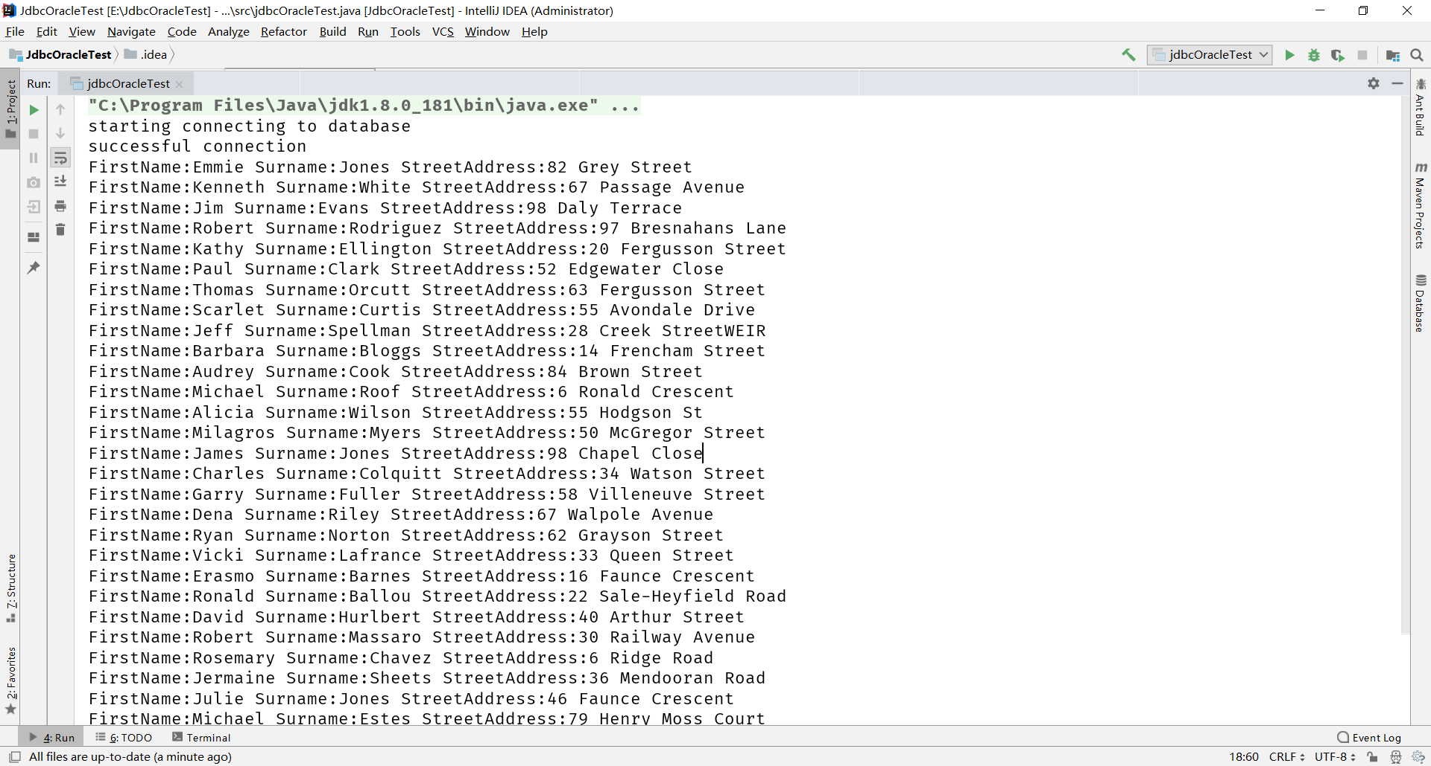

The picture is the result of all firstname , streetaddress and surname of users.

#### Application 2

Unzip the file and open the javaweb.

Java environment configuration:

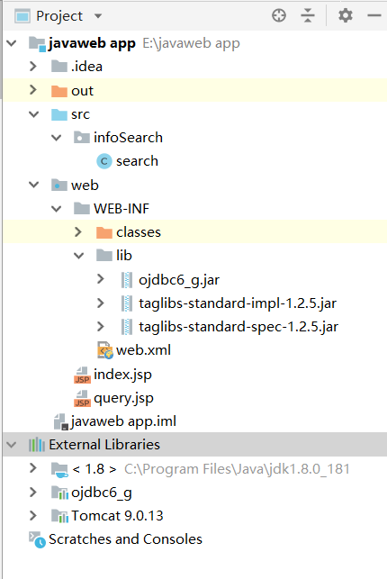

The design idea is use the index.jsp as beginning page to call servlet (search),and the servlet(search) will call query.jsp to display the results of searching on surname

click the Run button.And search <http://localhost:8088/javaweb> in the explorer.

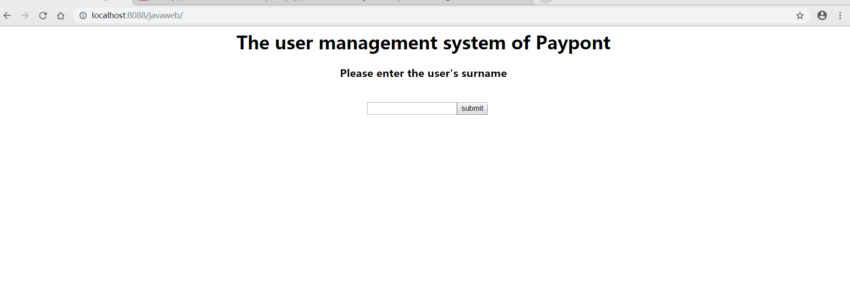

The index.jsp :you can enter the surname of user you want to search for.

for example : Clark

enter Clark and click submit

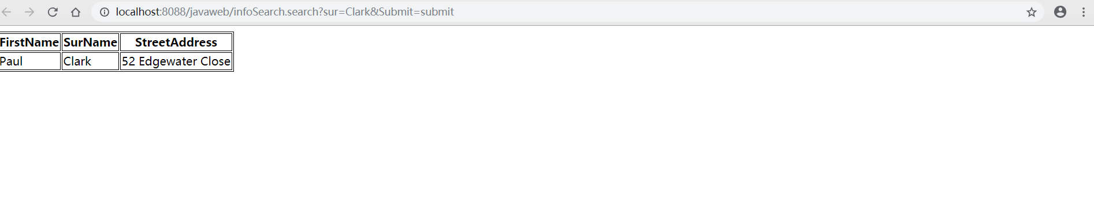

The query.jsp page will display the results.